**VI. EXPERIMENTAL PROCEDURES**

Copy/paste/type your own merged version of experimental procedures given in the following

entire section. Section VI has instructions on which procedures to follow or skip. Leave some

spaces as needed to handwrite your data and notes. To eliminate confusions just follow

procedure in section VI instead of previously used University of Michigan laboratory manual.

**PART 1. *What is a Precipitate?***

Your goal is to design experiments and use your logic to determine precipitate identity.

**a. Information (see reference Chapter 4, Table 4.1, page 121 of VC210 textbook)**

+ + -

Potassium (K ), sodium (Na ) and nitrate (NO3 ) ions are highly soluble (see references).



**b. Procedure**

Each 2 students in a group must test 1 sample once, so each group will test 2 samples (once

each).

**CAUTION**

Do not dump any of the reagents down the sink.

Discard the waste in an appropriate waste container.

Do not allow the solutions to come in contact with your skin.

1. Obtain 5ml of 0.1M copper sulfate, CuSO , and 5mL of 0.1M

4

barium chloride, ${BaCl}_{2}$. Record the appearance of each solution.

2. Combine each solution into one small beaker. Record your

observations. Label and save the mixture for later use.

3. Assuming that the reaction involves the coming together of ions

in solution, what ions could have combined to form the precipitate?

4. Separate the reaction mixture by filtration (see demo figures on the

right and also see end of experiment). Record the observable

properties of the filtrate. What conclusions can be drawn from your

data regarding the filtrate product species?

5. Write a chemical equation which represents the reaction and is

supported by your data

**PART 2.A. *Is Precipitation Predictable?***

In this experiment you will be asked if precipitation of a salt is a predictable event? For example,

is precipitation of a salt predictable from structural characteristics of its cation such as its charge

or ionic radius and/or from the position of its element in the periodic table? If you determine that,

tendency to precipitate and cation structure is linked, you should be able to correctly make

precipitation predictions about untested salt samples. You should also be able to identify an

unknown salt based on its precipitation behavior.

**a. Information**

When a salt dissolves, the partial positive and negative charges of water

molecules provide a substitute for the charges (ions) in the solid salt. The

negative poles of some water molecules attract the positive ions (cations)

while the positive poles of some water molecules attract the negative ions (anions) in the solid

salt (see figure on the right). This water-ion attraction cloaks each ion on the surface of the

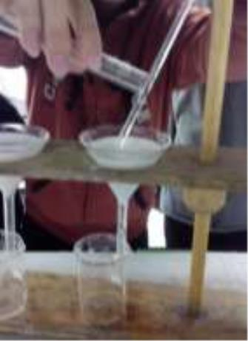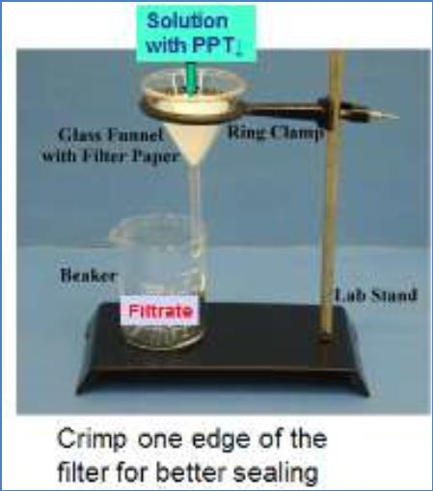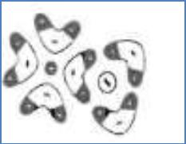

crystal with water molecules, and the ions are pulled into the water phase. The independent ions,

now sheathed in water molecules, are free to move about in the water.

In a precipitation reaction, the process is reversed. Thus dissolving and precipitation are

opposing processes. The more soluble a salt is, the less likely it will precipitate. Similarly, a salt

that readily precipitates must not be very soluble.

Teams are to gather information about the solubility and precipitation behavior of a group of

cations (Group I or II below -instructor assigned). In order to ensure that you are looking at

cation (and not anion) effects every team will use the nitrate salts of all of the varying cations

**Cation Groups (0.1M nitrate salts): Skip Hg2+ & Cd2+, then use Mn2+ instead of Li as**

**+**

$$I$$

$$II$$

Na

+

$${Ba}^{2+}$$

$${Li}^{+}$$

$${Mg}^{2+}$$

$${Ca}^{2+}$$

$${Co}^{2+}$$

$${Sr}^{2+}$$

$${Ni}^{2+}$$

$${Cr}^{3+}$$

$${Cu}^{2+}$$

$${Fe}^{3+}$$

$${Hg}^{2+}$$

$${Zn}^{2+}$$

$${Al}^{2+}$$

$${Ag}^{+}$$

$${Pb}^{2+}$$

$${Cd}^{2+}$$

$$K^{+}$$

**Anion Groups (0.1M sodium salts)**

In order to ensure that you are looking at anion (and not cation) effects every team will use

sodium salts of tested anions.

**b. Notes to the Procedure**

***Very much the same as c. Procedure except as following:***

a. Each group will test precipitation of either cations (I) or

cations (II) **but not both** (procedure says both). Either cations (I) or (II) tested with all

the **6 anions** as shown by the procedure. Groups must alternate using either cations (I) or

(II) but share the results with the other group (but not the rest of the groups). For

example Group #1 may select cations (I) to test, then Group #2 must select cations (II).

Both Groups must accumulate and share the observation data for cations (I) & (II) and

make it part of their discussions, but no need to tabulate the other group data on their

report. So each group will submit their own experimental results for either cations (I) or

cations (II) but not both.

b. The procedure shows 9 cations for (I) or (II). For safety reasons you will test 8 cations of

(I) or 8 cations of (II), omitting ${Hg}^{2+}$& ${Cd}^{2+}$ from all parts of the experiment. Also ${Li}^{+}$ is

replaced with ${Mn}^{2+}$. Each cation in (I) or (II) is to be **tested once**. So each student in a

group should test ***two different cations*** to precipitate, a total of **8 cations per group**.

c. Students must prepare master table reflecting the instructions, share the results within the

group and within the next group. You must show on your own table the precipitate color

if any, solution color & write no precipitate (**no ppt**) if there is none for specific samples

(see ${Ag}^{+}$ example in Table 2). The procedure has the list of the cations and anions to be

+

tested and has an example (omitting ${Hg}^{2+}$& ${Cd}^{2+}$ and replacing Li with ${Mn}^{2+}$ from all

parts of the entire experiment).

d. **Steps 1 thru 7** remain the same as the procedure. However, in **Step 4,** you will not need

to use a disposable pipet because the solution agents are housed in bottles that have an

eye dropper-like-lid ready to drop the agents (**only use 2 drops from each tested agent**

**bottle per tested sample)**. In **Step 6**, avoid repeating test results unless results are

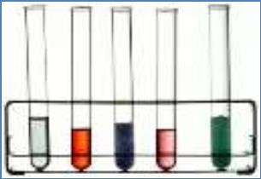

erroneous and the instructor authorizes you to do so and to minimize chemical waste.

Work diligently.

**e. Complete the *Data Analysis* 1 & 2** but skip the ***Optional Points to Consider*** section.

***Tabl1: CATION GROUPS TO PRECIPITATE* (0.10 M nitrate salts for each cation).**

**GROUP**

**Na**

**+**

$${Ba}^{2+}$$

$${Mg}^{2+}$$

$${Ca}^{2+}$$

$${Co}^{2+}$$

$${Sr}^{2+}$$

$${Ni}^{2+}$$

$${Cr}^{3+}$$

$${Cu}^{2+}$$

$${Fe}^{3+}$$

$${Al}^{3+}$$

$${Pb}^{2+}$$

**I**

**GROUP**

**II**

**K**

**+**

$${Mn}^{2+}$$

$${Zn}^{2+}$$

$${Ag}^{+}$$

***Table 2: ANION GROUPS PRECIPITATING* (PPT) REAGENTS*: (0.10 M sodium salts for**

**each anion). Select cations group I or group II but not both, then add your observations on**

**the table according to instructions & using group II example for Ag+ (caution: colors may**

**not be as shown). Compare your results with the other group I/II. Clear means no**

**precipitate (ppt).**

**CATION CATION**

**REF**

**Cl**

**-**

**CrO42-**

**I**

**-**

**C O42-**

**S**

**2-**

**SO42-**

**SPCTR**

**GROUP GROUP**

**II**

**SPCTR**

**2**

**GROUP I GROUP 2drops 2drops 2drops 2drops 2drops 2dro 2drops**

**I**

**ps**

**2drops**

**II**

**2drops**

**Na**

**+**

**K**

**+**

**clear**

**clear**

**clear**

**clear**

**clear**

**clear**

**clear**

**clear**

$${Ba}^{2+}$$

$${Mg}^{2+}$$

$${Co}^{2+}$$

$${Ni}^{2+}$$

$${Cu}^{2+}$$

$${Al}^{3+}$$

$${Mn}^{2+}$$

$${Ca}^{2+}$$

$${Sr}^{2+}$$

$${Cr}^{3+}$$

$${Fe}^{3+}$$

$${Zn}^{2+}$$

$${Pb}^{2+}$$

**Ag**

**+**

**White Brown Yellow White Black White**

**ppt↓** **ppt↓** **ppt↓** **ppt↓** **ppt↓** **ppt↓**

*precipitation reagents are 0.10 M sodium salts of the anion.

**c. Procedure**

1. Record a hypothesis regarding the question “is precipitation

predictable?" Make sure your hypothesis is precise and relates

precipitation to some cation characteristic. For example,

Your hypothesis might include "the [greater/less] the__

[characteristic of a cation that can be determined from the

position of its element in the periodic table], the greater it's

tendency to precipitate".

If your hypothesis is correct which four of your nine assigned

cations are less likely to precipitate?

2. **Use Table 2 above** to record your results (or if you want you may prepare a page sized table

(8.5 x 11") that includes seven columns (one reference column for your assigned cations. and

one column for each precipitating reagent), and nine blank rows. Make a copy of your form.)

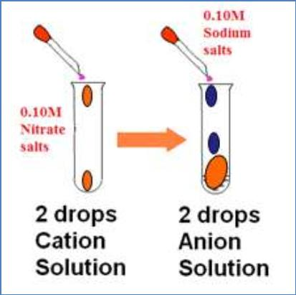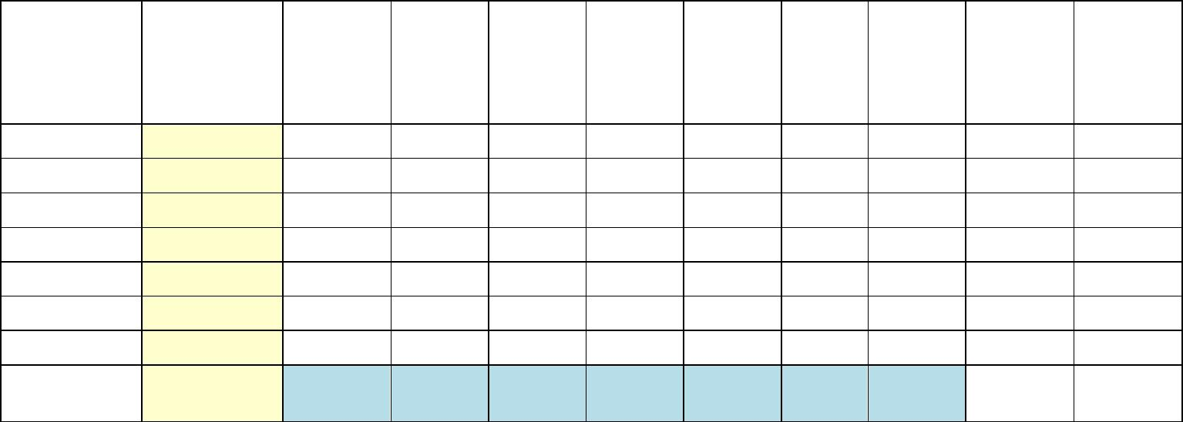

3. Identify the spectator ions (cation and anion) that are common to all your assigned (cation

and anion) group reagents.

4. Place your data table on a flat surface and cover it with a clean plastic sheet (a heavy plastic

sheet such as an overhead transparency works well).

**CAUTION**

Do not dump any of the reagents down the sink!

Discard the waste in an appropriate waste container!

Do not allow the solutions to come in contact with your skin! Wear gloves!

(Silver ion, Ag , will discolor your skin. Some ions are toxic).

+

Add two drops of your first cation solution (Cation Group I: start with 0.1M sodium nitrate,

NaNO or Cation Group II: start with 0.1M potassium nitrate, KNO , as assigned) to each

3

3

column of the first cation row. Do the same for the other rows, substituting the appropriate cation

solution.

5. Do not add any precipitating reagent to the first column (REF 2 drops: reference column). To

each cation solution in the second column add two drops of 0.1M sodium chloride, NaCl.

Add 2 drops of one of the other 5 precipitating reagents to each cation solution in the

appropriate column. Do not touch the tip of the eye dropper to the cation drops or you will

contaminate the precipitating agent!

6. Repeat any tests until you reach a team consensus. Record your observations (above table).

Has a precipitate (ppt.) formed? Indicate "ppt↓", "none" or "unsure". Record the ppt. color.

Do not discard your data table! Save your data table to refer to while conducting **Part I.B**.

7. Optional: Enter your team's data into the class data base (use a computer if available). Obtain a copy

of the summarized class data and record your analysis of the data (see directives below).

**d. Data analysis**

1. Obtain the class data. Compare the tendency to

precipitate of cations from elements in families

1, 2, and 12 of the periodic Table. Enter the

class data results into the periodic table below.

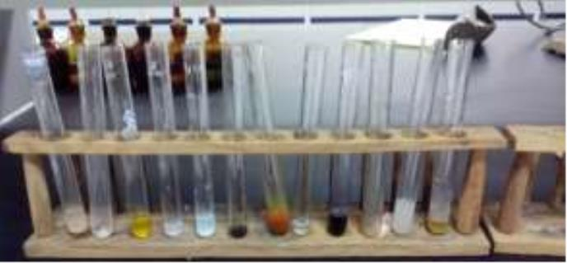

Is there an observable pattern in the data? Take care to consider that the number of reported tests

for each cation or number of tested cations per family may not be the same

2. Does the class data validate or dispute your recorded hypothesis regarding precipitation?

Why?

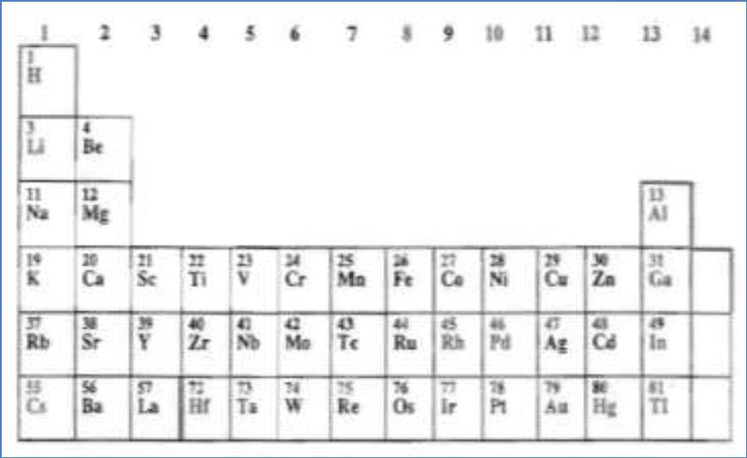

**PART 3. *Concentration and Precipitation*.**

Your task is

precipitation of ions at varying

concentrations. Is there some

to

investigate

minimum concentration of ions

required for precipitation? Can toxic

ions be completely removed from

water by precipitation?

**a. Information**

Each team is to investigate a specific precipitation reaction (instructor assigned). Varying team

results will be shared and the resulting data bank used for analysis of results.

**b. Notes to the Procedure**

***Very much the same as procedure except as***

***following:***

Your task is to investigate precipitation of ions at

varying concentrations:

***____Is there some minimum***

***concentration of ions required for***

***precipitation?***

***____Can toxic ions be removed from***

***water by precipitation?***

Use the same instructions as the procedure except with few minor changes that the instructor has

to approve your plan of work before starting the experiment. Four students/group need to design

their own concentrations of select solutions that are shown by the first column of Table 3 below

(Reactions # I through # VI (six reactions)). Then follow the instructor’s clarifications of the

manual instructions briefly described below:

a. Each group must select only three types of reactions from the left column of Table 3 and

carry on the experiment using the corresponding reactants shown by the rows of Table 3.

b. Each reaction will be tested mostly with three or two different concentrations of reactants

as directed by your instructor and according to the lab inventory availability of the

reagents. Typically you will start reactions using 1 M reactants then dilute down

reactants to 0.1 M & 0.01 M concentrations.

c. The TA’s will instruct you how to work together and approve the design of your own

select reactions. A group will end up doing either 8 or 9 different reaction trials,

depending on dilution limits, so each student will do at least 2 different reactions. Each

group designs the reactants to differ by composition and by concentrations. Here groups

should alternate reactions and compare results with each other.

d. For many of the reagents you may have to dilute with de-ionized water to reduce (vary)

concentrations using your skills (C xV = C xV ). Stock reagents are mostly available a

1

1

2

2

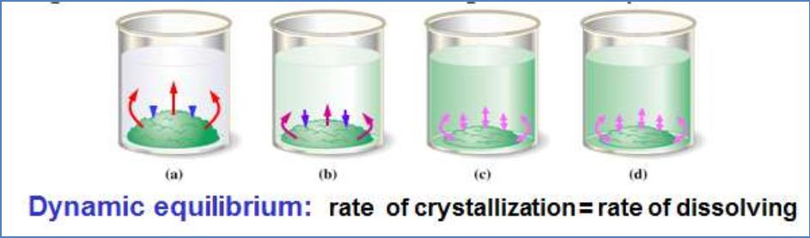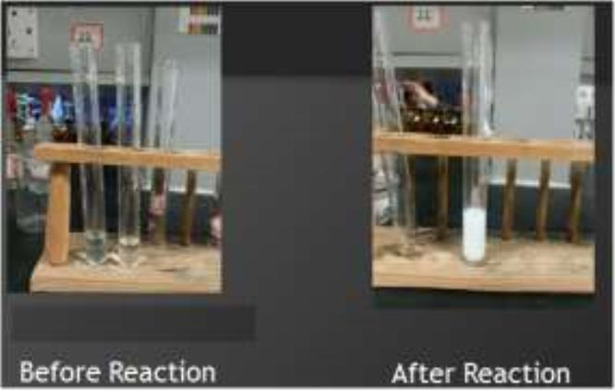

1M solutions or 0.1M, check with the instructor for availability but each group must test

8 samples.

e. Add only 2 drops of each the reactants for each of the reactions and do not waste

chemicals.

f. Table 4 and Table 5 may be used as an example to design your own reactions as

described above. Report your observations of the reactions to your instructor and

complete your report information as instructed by the lab manual.

g. The instructor will guide you through next sections: ***c. Procedure*** (steps 1-3), ***d.***

***Additional Information*** (steps 4&5), ***e. Data Analysis*** (steps 6 & 7). **Skip: *f. Extensions***

(8-10), and **Skip: *g. Optional Points to Consider*** (steps 11&12).

h. ***Be diligent to safe chemicals & time. Do not repeat trials without the permission of***

***instructor.***

**CAUTION: Do not dump any of the reagents down the sink! Discard the waste in an appropriate waste**

**container under the supervision of your instructor! Reduce waste by working diligently and do not repeat**

**experimental trials without the approval of the instructor. Do not allow solutions to come in contact with**

**your skin! Wear gloves & goggles! (Silver ion, Ag+, will color your skin. Some ions are TOXIC).**

**TABLE 3:** Team reactions (some reactants are different than those used in the UM lab

manual because of the availability of inventory).

REACTION #

I

II

III

IV

V

REACTANT #1

Pb(NO3)2

Pb(NO3)2

AgNO3

ZnSO4

CaCl2

REACTANT #2

KI

NaOH

KI

NaOH

K C

2

2

VI

CaCl2

NaOH

***TABLE 4:*** Example of reactions that may be selected by a particular group of your class, say

Group # 5.

**REACTION REACTANT #1 REACTANT #2**

**#**

**OBSERVATIONS**

**II-1**

**II-2**

**II-3**

**IV-1**

**IV-2**

**IV-3**

**V-1**

0.10M Pb(NO3)2

0.10M Pb(NO3)2

0.01M Pb(NO3)2

0.10M ZnSO4

0.10M ZnSO4

0.01M ZnSO4

0.10M CaCl2

0.10M NaOH

1.0M NaOH

0.01M NaOH

0.10M NaOH

1.0M NaOH

0.01M NaOH

0.10M K C O

2

2

4

4

**V-2**

0.01M CaCl2

0.01M K C O

2 2

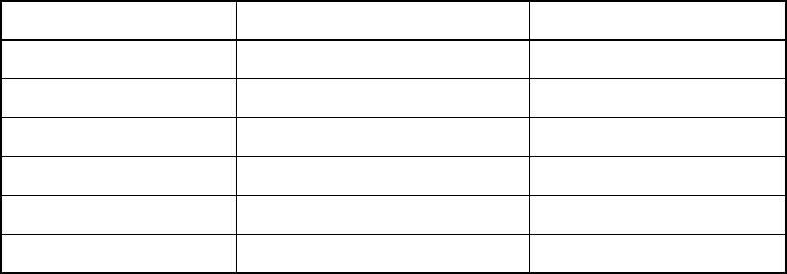

***TABLE 5:*** Another example of alternative reactions that may be selected by next group of your

class.

**REACTION REACTANT #1 REACTANT #2**

**#**

**OBSERVATIONS**

**I-1**

**I-2**

**I-3**

**III-1**

**III-2**

**III-3**

**VI-1**

**VI-2**

0.10M Pb(NO3)2

0.10M Pb(NO3)2

0.01M Pb(NO3)2

0.10M AgNO3

0.10M AgNO3

0.01M AgNO3

0.10M CaCl2

1.0M KI

0.10M KI

0.01M KI

1.0M KI

0.10M KI

0.01M KI

0.10M NaOH

0.01M NaOH

0.01M CaCl2

**CAUTION**

Do not dump any of the reagents down the sink!

Discard the waste in an appropriate waste container!

Do not allow solutions to come in contact with your skin!

**c. Procedure**

1. In a small test tube add 10 drops of reactant #1 to reactant #2 (both

reactants at 0.10M). Shake well. Record the amount of precipitate as

"lots", "slight", "none, or "unsure". Identify the reacting ions and

products. Label and save the precipitated mixture.

2. Discuss and record your team's hypothesis about concentration and

precipitation. What do you expect to observe as you repeat the

reaction at higher and lower ion concentrations?

3. Repeat the reaction using both reactants at equal concentrations

above and below 0.10M. Record a team consensus about the amount

of ppt as "lots", "slight", "none", or "unsure". Label and save any precipitated mixture.

**d. Additional Information**

If < 0.10M reagent is not available, dilute the 0.10M sample. (for example, 2 drops of 0.10M

reagent + 18 drops of distilled water = 0.010M)

If > 0.10M reagent is not available, add a few crystals of the solid to its 0.10M reagent.

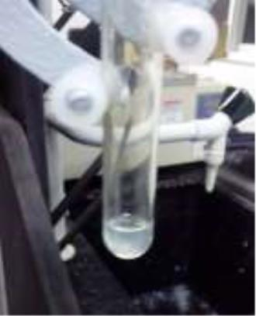

5. Enter your team's data into the class database (use a computer if available). Obtain a copy of

the summarized class data and conduct an analysis of the data (see directives below).

**e. Data analysis: Use Table 3, Table 4 & Table 5 to record your results**

6. Obtain the class data do you observe patterns in the data regarding concentration effects and

precipitation? For example, does precipitation of all salts occur within the same

concentration values? Does the amount of precipitate increase or decrease with increase in

concentration? Are all ions removed from solution upon precipitation?

7. Does the data support or contradict your hypothesis regarding concentration and

precipitation? Explain your reasoning.

**PART 4. *Solvent Pollution & Precipitation***

A drum containing a solvent other than water is accidentally dumped into a pond of water

containing dissolve salts. What, if anything, will happen? In inquiry you will compare the

solubility and precipitation of salts in different solvents (water, acetone and, hexane).

**a. Information**

Water is polar; Acetone (CH COCH ) is moderately polar; hexane (C H ) is nonpolar.

3

3

6

14

Your team should investigate the same reactants assigned in **Part 3**.



You will need 5-6 crystals of each assigned reactant

You will need about 4ml (80 drops) of each sol vent

**b. Notes to the Procedure**

***Very much the same as procedure except as following:***

Follow the instructor’s directions that he will guide you through the procedure shown in the

procedure next, and he may ask you to skip some steps (SKIP STEP 9). Group work: for each

reaction (in water or in acetone or in hexane) each group tests the solubility of two solids

separately (CaCl & K C O ), where each two students of the group test one solid while the other

2

2

2

4

two students test the other alternative solid. Complete Table 6 for each group results.

**TABLE 6: *Solids Solubility in Polar & Non-Polar Solvents (total 6 samples to test)***

**Solid Type**

**I.CaCl2**

**Ionized Water**

**Acetone**

**Hexane**

**II.K C O (potassium**

**2**

**2**

**4**

**oxalate)**

**Supernatant (I + II)**

**c. Procedure**

1. Record your hypothesis regarding effect

of varying solvent polarity on solubility

and precipitation of salts. If your

hypothesis is correct what will you

observe? For example, will precipitation

occur in all solvents? Will the amount of

precipitate differ?

2. Test and compare the solubility of your

assigned salt reactants in water, acetone,

and hexane.

**CAUTION**

Acetone and hexane are volatile!

Do not inhale acetone or hexane keep the samples closed or use a hood!

Do not dump acetone or hexane down the sink!

Discard the acetone or hexane in an appropriate (organic) waste container!

Add a few crystals of reactant #1 to each of three separate dry test tubes labeled water, acetone

or hexane. Add= 2.0mL (40 drops) of water or acetone or hexane to the crystals.

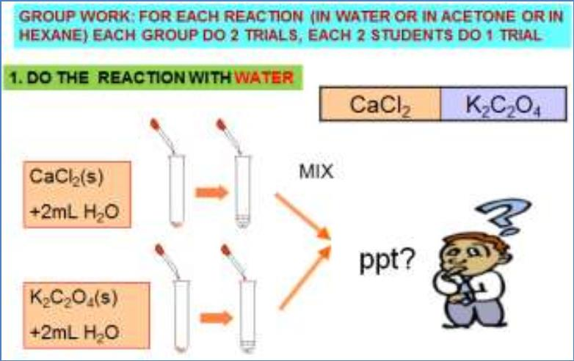

Mix vigorously. Record your observations. Are the crystals “insoluble”, “slightly soluble” or

“soluble” in each testing solvent? Save the labeled samples for later use.

Repeat the tests with reactant #2. Save the labeled samples for later use.

3. Separate any undissolved solid from the solvent solution

(containing dissolved crystal). For example, pipet or

decant off the supernatant liquid (the clear solution above

any undissolved solid) into clean and dry test tubes or

containers (labeled to identify the contents).

4. Test and compare the effect of solvent environment on

precipitation. Combine the clear liquids of reactant #1 and

#2 from the same solvent mixture (e.g. water with water

or acetone with acetone or hexane with hexane). Does

precipitation occur? How much? Record "lots", "slight",

"none", or "unsure", repeat any tests until you reach a

consensus.

5. Do your team results show any pattern between

precipitation (step 4 above) and solubility (step 3) of the

salts in a given solvent

6. Enter your team's data into the class database (use a

computer if available). obtain a copy of the summarized

class data and conduct an analysis of the data (see

directives below)

**d. Data Analysis**

7. Are any visible patterns in the class data regarding

effect of solvent polarity on solubility and precipitation

of salts? Record any data patterns and give specific

examples.

8. Does the class data confirm or deny your recorded

hypothesis? How do you know?

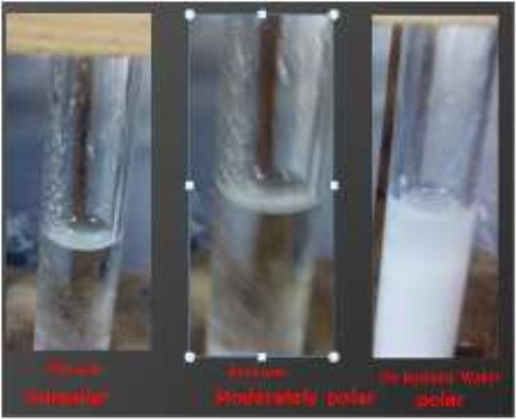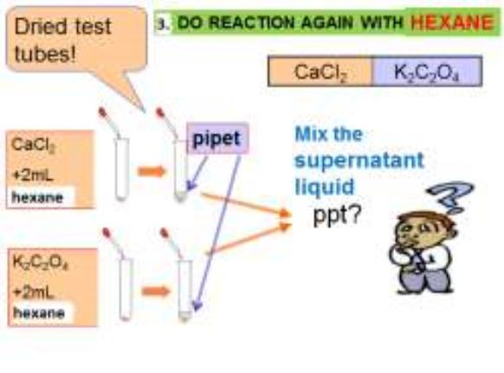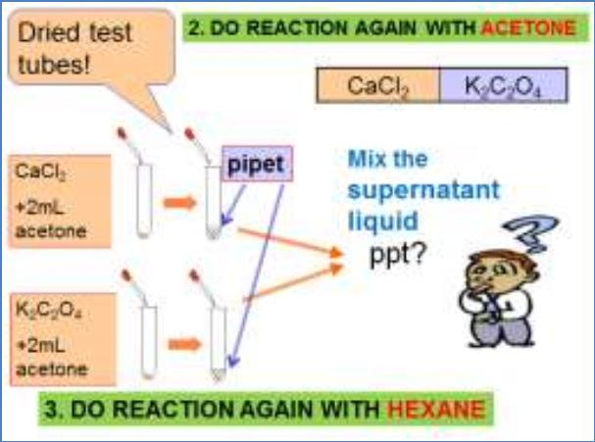

***Collect all your results as instructed on the first page of this experiment and complete your***

***final lab report by adding and answering the next section VII. Then hand deliver the report to***

***your instructor. No reports will be accepted after the end of this lab session.***

***Prepare all needed tables and report format ahead of the lab session so you can***

***be ready to enter & share collected data.***

NOW CONTINUE TO FINISH ALL THE NEXT SECTION VII.

REPORTS OF RESULTS

